5

Procedure Checklist
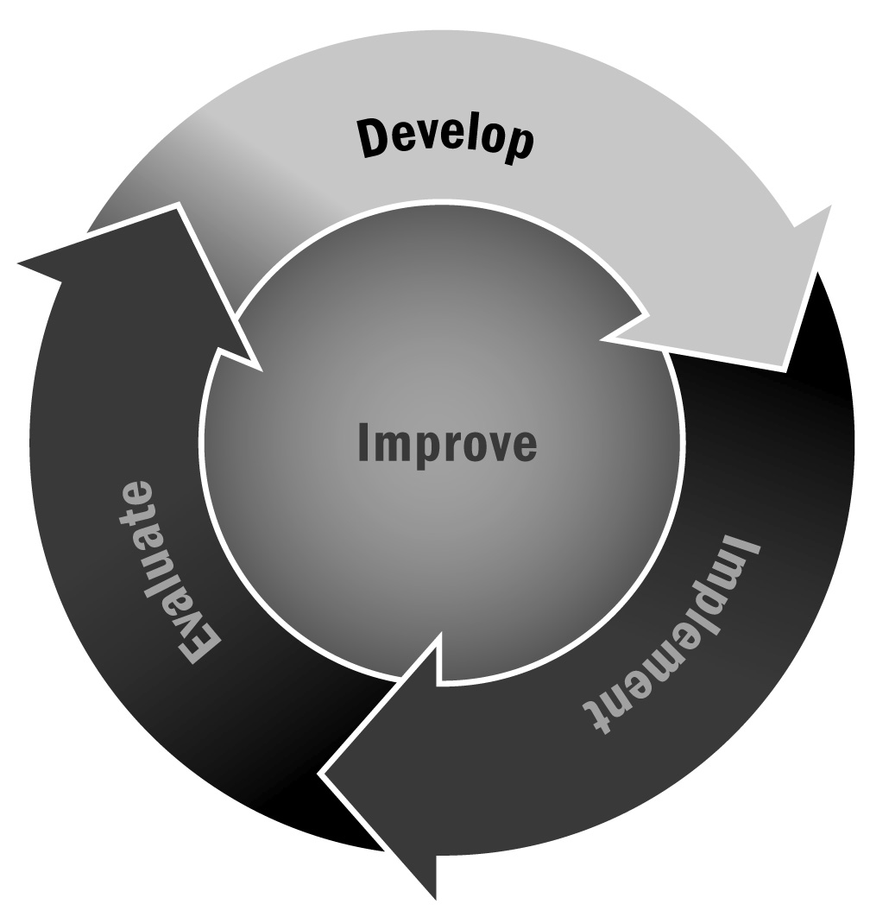
In Chapter 1, you learned that it is important to craft procedures so that staff members understand how to implement or support existing policies. In some cases, however, it might be better to let your staff members develop their own procedures rather than prescribing one for them. Use this checklist to help you determine whether you should establish a specific procedure or leave your staff with flexibility to define procedures locally.
Directions: First, describe the policy or issue in question in the space provided. Then, place a checkmark next to each question for a “yes” or “no” answer. When you are finished, tally your “yes” checkmarks. If you have four or more “yes” checkmarks (particularly if it is a legal liability question), you may want to consider establishing a procedure.

Policy or Issue

 | Yes | No
Is it a matter that will directly affect the health and safety of participants or the staff? | ❒ | ❒
Is it a situation that occurs on a regular basis? | ❒ | ❒
Would law enforcement officials or attorneys suggest that it should be a policy? | ❒ | ❒
Could flexibility on this matter lead to inconsistent or conflicting practices? | ❒ | ❒
Are your staff members relatively inexperienced in this area? | ❒ | ❒
Do your staff members have difficulty taking initiative or responsibility without direction? | ❒ | ❒
Is this a matter that could result in liability for your program? | ❒ | ❒
Is this a matter that could be interpreted in a variety of different ways? | ❒ | ❒
Would families be likely to want a clear procedure in place? | ❒ | ❒

Total Number of “Yes” Answers: ____________

